**If “File -> Load Project” and “File -> Save Project” doesn’t do anything in Safari, then it might be because you’re running Adobe Flash for machinelearningforkids.co.uk in “Safe Mode”.**

Safe Mode prevents flash from reading or writing the files on your computer, which stops the File Save and Load dialogs from being able to open.

**This Help doc explains how to turn this off just for this site, and get the Load/Save working again!**

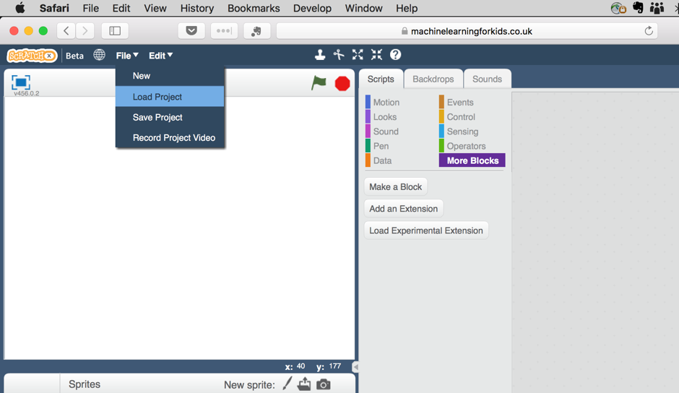

**Step 1 – go to the Preferences dialog for Safari**



**Step 2 – click on the Flash Player plugin in the Websites tab**



**Step 3 – hold down the “alt” or “Option” key on your keyboard**Keep it held down while you do Step 4!

**Step 4 – click on the drop-down list for “machinelearningforkids.co.uk”**

If “Run in Safe Mode” is ticked, then this is why you can’t Load or Save projects in Scratch.



**Step 5 – click on “Run in Safe Mode” to untick it**

The warning tells you that this will let Scratch access files on your computer. This is what you need to be able Load and Save Scratch projects.



**All done!**

Scratch should now be able to load and save projects again.

